NMCS Component Test Framework (NMCS_CTF)

Table Of Contents

Introduction: 2
Scope: 2
Test Strategy: 2
Block Diagram: 6
Class Diagram: 7

Introduction:
NMCS Component test Framework explains about the Test strategy/procedure that need to be followed to perform the Component/Module test of individual features of various subsystems present in NMCS.

Scope:
At present this Framework (NMCS_CTF) is developed for testing NMCS Communication Framework subsystem. Later this can be extended to any other NMCS subsystem.

Test Strategy:
NMCS_CTF shall render the following services for a particular subsystem of NMCS:
- Executing the specified individual/Selective Component Test cases and reporting the result
- Executing all automated Component Test cases and reporting the result
- Executing the manual test cases with human input/intervention and reporting the result
- Choice for writing the test output to Console.

To perform the all above mentioned operations, NMCS_CTF tool shall require an input file called “NMCS_<SubsystemName>_CTFInput.txt”. It produces the output/Result file “NMCS_<SubsystemName>_CTFOutput.txt”.

For CF this can be “NMCS_CF_CTFInput.txt” and “NMCS_CF_CTFOutput.txt”. For Alarms it is “NMCS_Alarms_CTFInput.txt” and “NMCS_Alarms_CTFOutput.txt” so on.
Content of “NMCS_CF_CTFInput.txt” file is shown as a sample in the next page.

NMCS_CTF tool will not read a line that starts with # character in “NMCS_<SubsystemName>_CTFInput.txt” file. Any comments (Specific to test cases also) can be added to the input file by putting # in the beginning of the line. Users can “Turn OFF” a particular test (May be required if a particular feature is not supported now/available in future or is removed from the feature list) by putting # in front of its TestCase_Number as seen below. (TestCase_Numbers 1.3 and 6.2) Here the TestCase_Numbers are taken from CF_Component_TestCases.xls file.

#It is a comment; NMCS_CTF tool will not read the line that starts with #
NMCS Component Test Environment details
NMCS Version_Number:2.0
NMCS Build_Number:4.5
CF Build_Number:3.2
OS Used:NT
Need_Selective_Testing:Yes
TestCase_Numbers: 1.2, 2.5, 6.1
Need_Console_Output:Yes
#Following Automated test cases will be executed in a sequence
#Please follow the below order/format for each test cases
#Testcase: Testcase Number
#{
#Command1 param1 param2
#Command2 param1 param2
# .. .. ..
#}
Testcase: 1.1
{
Connect NewStructService_Instance 132.186.193.203
}
Testcase: 1.2
{
Set C1 Connect Counter_Service
@C1 localhost
ExecuteProperty Set Interval 500
}
#Testcase: 1.3
{
@C1 132.186.193.203
ExecuteProperty SetPriority High
Set C3 Disconnect
}
Testcase: 1.4
{
Set C2 Connect DiskService localhost
ExecuteMethod Send "IO Error"
@C3
}
…
…
Testcase: 6.1
{
RequestReplyBlocking_Win32_C_Service.exe
RequestReplyBlocking_Win32_C_Client.exe
}
#Testcase: 6.2
{
….
….
}

NMCS_CTF tool uses the following details present in the beginning of input file for version documentation while reporting the test results. The tool simply copies it to the result output file by adding the date/time info to it.
NMCS Component Test Environment details
NMCS Version_Number:2.0
NMCS Build_Number:4.5
CF Build_Number:3.2
OS Used:NT

User/Tester may wish to execute all automated test cases in a sequence or in a selective manner (Individual/Random test cases) by specifying the Test case numbers as seen above. (TestCase_Numbers: 1.2, 2.5, 6.1) Here user wishes to execute the test cases bearing the numbers 1.2, 2.5, 6.1. For this purpose, user also need to specify “Need_Selective_Testing: Yes” if its value is “No” then tool will not do the selective testing. Once user specifies, “Yes” to “Need_Selective_Testing:” and gives the TestCase numbers, tool looks for those test cases in the input file and executes them if those test cases exist and they do not have # in front of them. If Test case is not found it reports an error.

While doing the Selective Testing user has the choice to write it to the console by specifying Need_Console_Output:Yes

If “Need_Selective_Testing: No” is set above then the tool executes the Automated test cases in a sequence as specified in the input file. While executing the test cases it needs each line to be in the below order/format.
Testcase: Testcase Number
{
Command1 param1 param2
Command2 param1 param2
.. .. ..
}

For e.g. in the line
Testcase: 1.1
{
Connect NewStructService_Instance 132.186.193.203
}

The service “NewStructService_Instance” is already started on the PC that has the IP address “132.186.193.203”. Here connecting to the service is nothing but executing the test case number 1.1.

Otherwise the testcase can also be specified in the below format-

Testcase:Testcase Number
{
ServiceExecutableName
ClientExecutableName
.. .. ..
}
Here the tool starts the service “ServiceExecutableName” and then the client “ClientExecutableName” to execute the test case “Testcase Number”. For e.g. in the line

Testcase: 6.1
{
RequestReplyBlocking_Win32_C_Service.exe
RequestReplyBlocking_Win32_C_Client.exe
}

The service “RequestReplyBlocking_Win32_C_Service” is started and the client “RequestReplyBlocking_Win32_C_Client” is then connected to execute the test case number 6.1.

For each test case that executed, the tool specifies its test case number, Test Status and Observation/Remark if any in case of failure.

The sample “NMCS_CF_CTFOutput.txt” file can look like this:

NMCS Component Test Environment details
NMCS Version_Number:2.0
NMCS Build_Number:4.5
CF Build_Number:3.2

OS Used: NT
July/20/2007,5:25PM

TestCaseNumber Test Status Observation/Remark
  - PASS
  - FAIL Connection Error
  - PASS
….
…
6.1 FAIL Message Corrupt

Block Diagram:

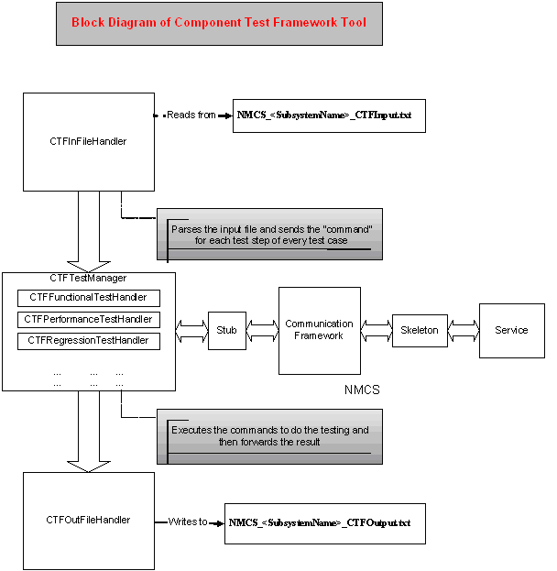
CTF tool consists of three main modules that are—
CTFInFileHandler: This module reads all testcases at a time from the input file, and passes it to CTFTestManager.
CTFTestManager: This module performs the actual component test based on the test steps (i.e. commands) specified in each testcase. Depending upon the user choice this module performs the Functional, Performance & Regression testing. Output is sent to CTFOutFileHandler module.
CTFOutFileHandler: This module writes the Component test environment details and the test results to the output file.

Class Diagram:

